Viewing Tours – Sprint 12 summary
This project focused on being able to book multiple units on a single viewing, enabling enhanced feedback collection, better calendar/diary management, and increasing reporting and visibility to all Grainger users.

Creating viewing tours
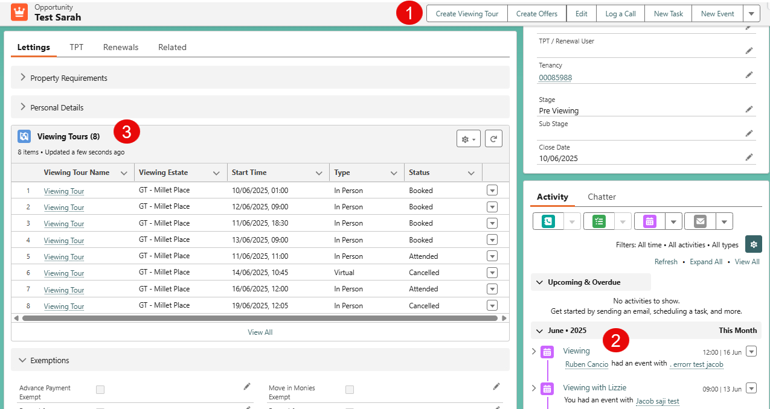Users will be able to see the Viewing Tours for an Opportunity in the Lettings Tab.

1. New Viewing Tour
Viewing Tours should be created from the Opportunity, where new functionality has been added so that key details are filled in automatically, such as the Contact Name. This previously was a pain-point where users would need to search for and potentially select the wrong person.
The related opportunity will also be updated so that the Stage will move to ‘Booked Viewing’, providing better visibility of the pipeline for Lettings Teams.

2. Viewing Event
Creating a Viewing Tour from the Opportunity automatically creates the event in the Owner’s calendar, and the existing functionality that sends emails to the customer all still triggers.

3. Viewing Tour Visibility
Users will be able to see the Viewing Tours for an Opportunity in the Lettings Tab.

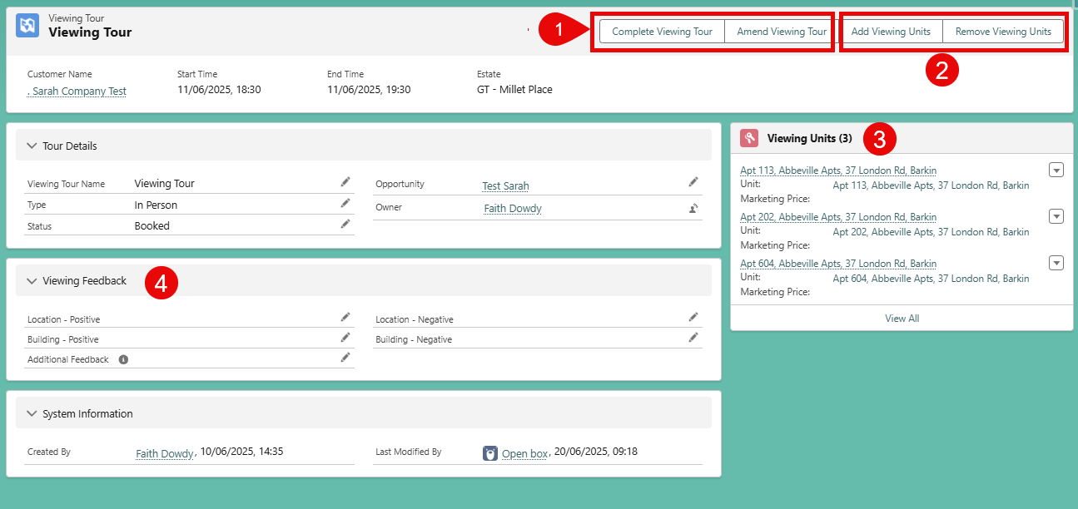Viewing Tour Record

1. Complete or Amend Viewing Tour
Users will Complete a Viewing Tour when the customer either attends or is a no-show. Either of these options will update the related opportunity’s Stage to ‘Post-Viewing’ or ‘Pre-Viewing’ respectively. This ensures that the Lettings Team’s Pipeline Reports are up to date, and they know which opportunities to focus on.
Amending a Viewing Tour allows the user to either change some details or cancel the Viewing Tour. Editing details will update the underlying event and if the date/time changes, the customer will continue to get the current emails.
Cancelling a Viewing Tour now removes the event, ensuring that the team have a clear and correct view of their upcoming Viewings in their Salesforce Calendars. Depending on the cancellation reason, the Opportunity is either Closed Lost or returned to ‘Pre-Viewing’, prompting the team to try and rebook another viewing.

2. Add and Remove Viewing Units
A key part of this project is being able to list the different units that are shown on the Viewing Tour. Users will be able to search for available units in a building, add multiple units to the Viewing Tour, as well as be able to remove any that are no longer valid or applicable to the tour. Both actions to add or remove Viewing Units is a single step – rather than the previous process where each unit shown would need to be created as its own separate viewing.

3. List of Viewing Units
Each Viewing Unit added to the Viewing Tour is visible on the side, and can be navigated to by the user.

4. General Feedback
Collection of Building or Block specific feedback can be recorded directly on the Viewing Tour. Unit specific feedback would be on the Viewing Units.

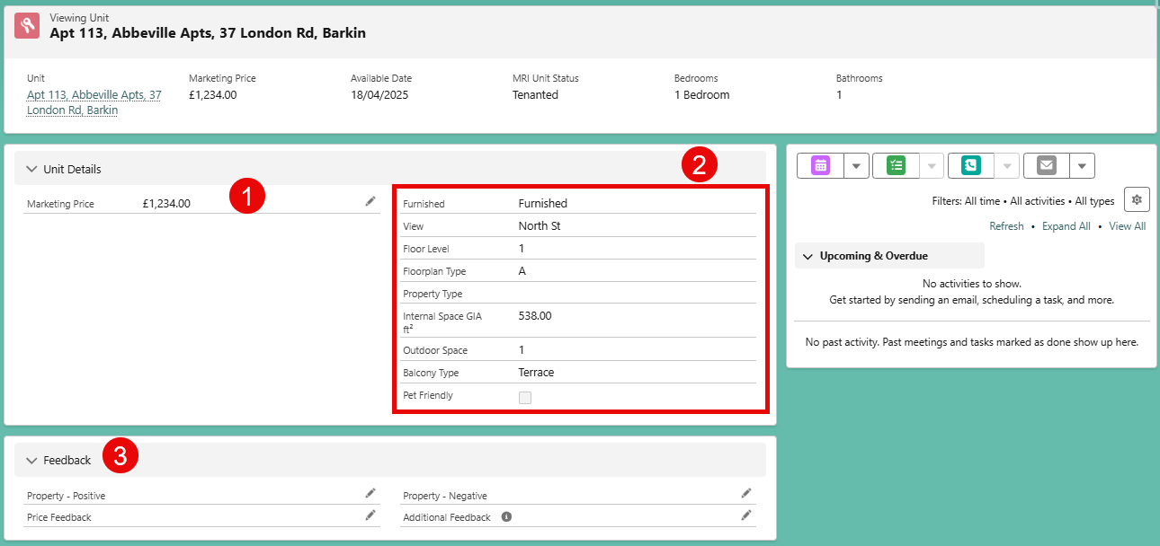Viewng Unit Records
The Viewing Unit allows the Lettings Team to be able to see the relevant information as well as capture feedback on units on their iPads whilst they are on the viewing.

1. Unit Marketing Price
Users should manually input the marketing price for the unit, depending on when the customer is looking to move in. In the future, this can be automatically populated with prices from the appropriate Pricebook.

2. Relevant Unit Details
Details from the Unit is pulled onto the Viewing Unit page, meaning that users do not have to move between different pages to see what they need – all viewing related details are right at their fingers.

3. Unit Specific Feedback
Feedback about specific units can be captured here. This feedback section allows for price feedback, positive and negative unit feedback, and additional comments. By having this on each record, in depth reporting can be built to see the common feedback for specific homes.

